Project Meeting Log
Team: Harkey-Sp26-1
Course: CMPE 295B
Project: TraceAdvisor: Pre-Execution Resource Recommendations for Recurring Cluster Workloads
Advisor: Dan Harkey (previously Guzun)
Team Members: Meghana Koti, Sofia Silva, Sonali Lonkar, Shivani Jariwala

Meeting 1: Team-Only – 2026-08-25
Meeting Type: Team-Only
Date: 2026-08-25
Start–End Time: 8:00 PM – 9:00 PM
Location/Mode: Zoom
Attendees: Meghana Koti, Sofia Silva, Sonali Lonkar

1) Accomplished Since Last Meeting
- Reviewed last semester’s code and found formula inconsistencies.

2) Accomplished During This Meeting
- Listed the corrections needed in the formulas, metrics and train/test intervals.
- Discussed an adapter interface for the Google/Azure datasets and a risk-aware hybrid policy.
- Agreed to focus on the regression models for the prototype.

3) Issues / Blockers
- The datasets have different schemas, and the Google dataset is outdated.

4) Action Items
- Action: Fix the formulas and update the status document | Owner: Meghana | Due: 08-27
- Action: Email the OpenStack dataset authors | Owner: Meghana
- Action: Submit the project status update | Owner: Sonali | Due: 08-28

5) Plans / Goals for Next Meeting
- Finalize the project status slides on Thursday.

Evidence: Zoom Screenshot
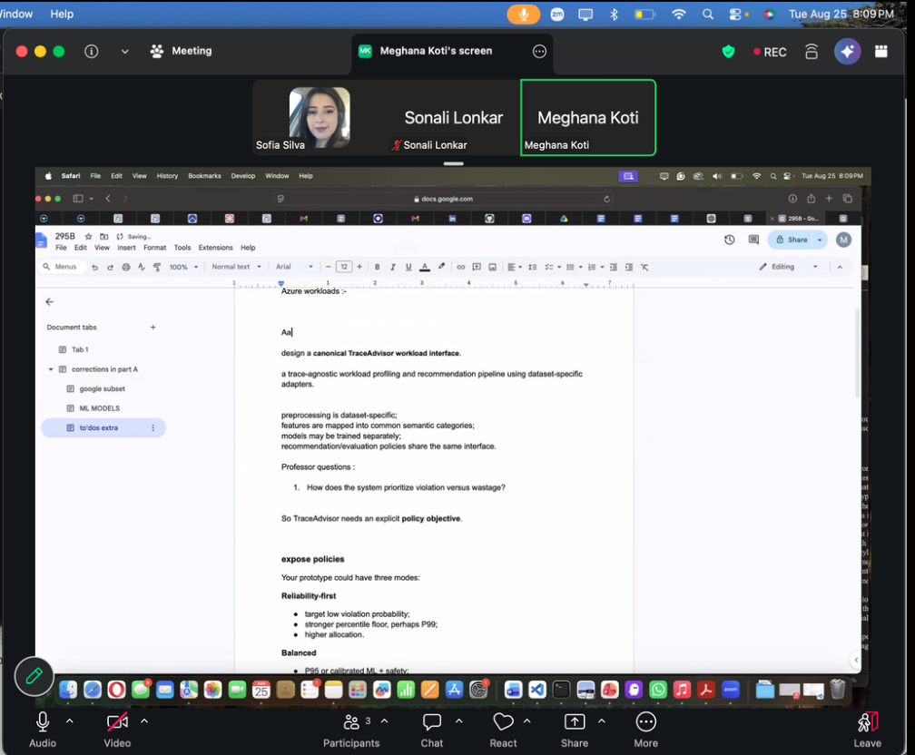

Meeting 2: Team-Only – 2026-08-27
Meeting Type: Team-Only
Date: 2026-08-27
Start–End Time: 8:00 PM – 9:00 PM
Location/Mode: Zoom
Attendees: Meghana Koti, Sofia Silva, Sonali Lonkar

1) Accomplished Since Last Meeting
- Meghana shared the 295B document and the draft project status slides.

2) Accomplished During This Meeting
- Reviewed the project status slides and agreed to put the details in the speaker notes.
- Started estimating completion percentages for the report chapters and the prototype.

3) Issues / Blockers
- The advisor (Guzun) hasn’t replied to the team’s emails.

4) Action Items
- Action: Add the content and completion estimates to the slides | Owner: Meghana | Due: 08-28
- Action: Review the 295B document | Owner: Sofia | Due: 08-28
- Action: Follow up with the advisor, and escalate to the course instructor if there’s no reply by next week | Owner: Team

5) Plans / Goals for Next Meeting
- Submit the project status update and continue the slide edits.

Evidence: Zoom Screenshot
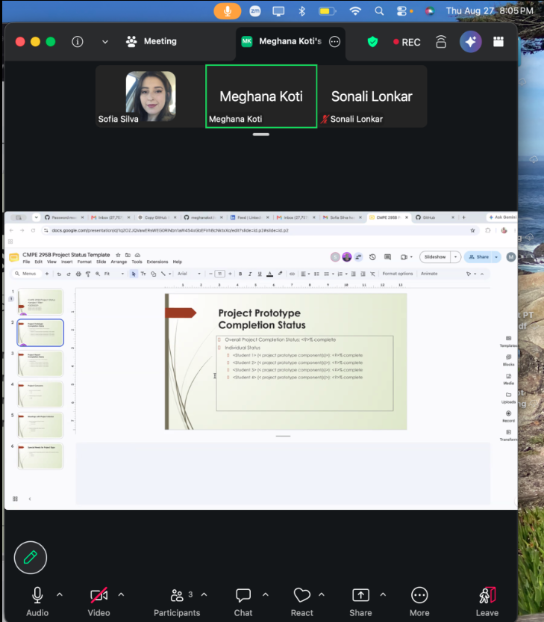

Meeting 3: Team-Only – 2026-09-01
Meeting Type: Team-Only
Date: 2026-09-01
Start–End Time: 8:00 PM – 9:00 PM
Location/Mode: Zoom
Attendees: Meghana Koti, Sofia Silva, Sonali Lonkar

1) Accomplished Since Last Meeting
- Submitted the project status update.
- The project was reassigned to a new advisor, Dan Harkey.

2) Accomplished During This Meeting
- Planned how to introduce the project to the new advisor, starting with the overview before the technical details.
- Agreed to split the code corrections by workbook tab, with each person working locally and opening pull requests.

3) Issues / Blockers
- The new advisor prefers research projects, so the project direction may need to change.

4) Action Items
- Action: Email the advisor with the workbook link and status PPT, and ask for his availability | Owner: Meghana
- Action: Send the final workbook link to Meghana | Owner: Sofia
- Action: Prepare 2–4 project ideas to present to the advisor | Owner: Team

5) Plans / Goals for Next Meeting
- Meet with the new advisor and get his feedback on the project direction.

Evidence: Zoom Screenshot
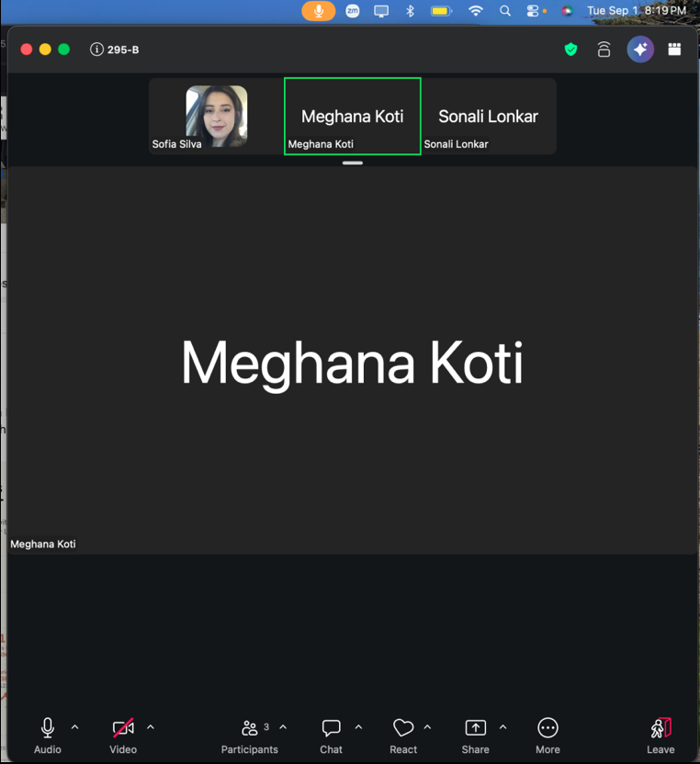

Meeting 4: Team-Only – 2026-09-08
Meeting Type: Team-Only
Date: 2026-09-08
Start–End Time: 8:00 PM – 9:00 PM
Location/Mode: Zoom
Attendees: Meghana Koti, Sofia Silva, Sonali Lonkar, Shivani Jariwala

1) Accomplished Since Last Meeting
- Contacted the new advisor, Dan Harkey, and scheduled an in-person meeting.

2) Accomplished During This Meeting
- Planned a shorter presentation for the advisor meeting, cutting it from 30 slides to 1–3 per notebook plus an architecture diagram.
- Agreed to add 2–3 slides on next steps for the semester.

3) Issues / Blockers
- The original presentation is long and hard to find, since it’s split between Discord and email.

4) Action Items
- Action: Create the new short PPT and share the link | Owner: Meghana
- Action: Find the original PPT in Discord or email | Owner: Sofia, Sonali
- Action: Review and finalize the PPT | Owner: Team | Due: 09-11

5) Plans / Goals for Next Meeting
- Present the project to Dan Harkey at the in-person meeting on Tuesday.

Evidence: Zoom Screenshot
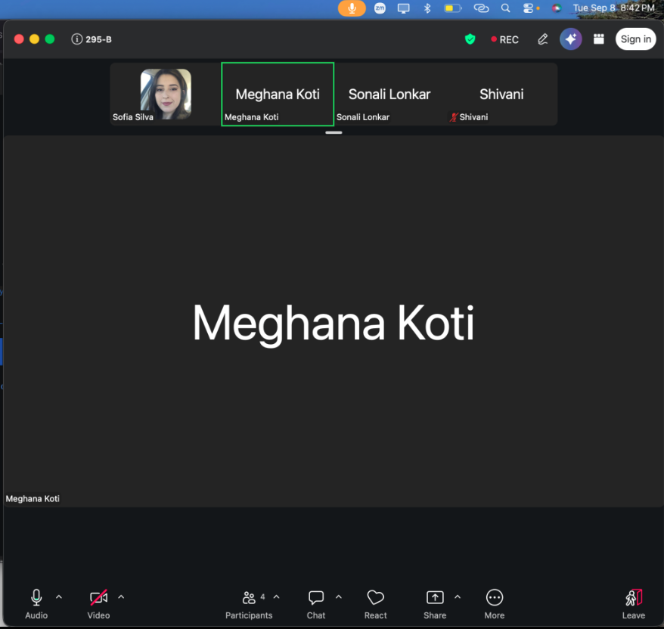

Meeting 5: Advisor – 2026-09-15
Meeting Type: Advisor
Date: 2026-09-15
Start–End Time: 9:30 AM – 10:00 AM
Location/Mode: Zoom
Attendees: Dan Harkey (Advisor), Meghana Koti, Sofia Silva, Sonali Lonkar, Shivani Jariwala

1) Accomplished Since Last Meeting
- Fixed the formula and metric inconsistencies, and prepared a short project presentation for the new advisor.

2) Accomplished During This Meeting
- Introduced the TraceAdvisor project and presented the semester plan for the Part B prototype.
- Set the goals for the week: refactor the pipeline, standardize the ML inputs, and start the common workload interface.

3) Issues / Blockers
- The ML feature sets were not consistent across models.

4) Action Items
- Action: Refactor the profiling and evaluation logic into reusable modules | Owner: Team | Due: 09-22
- Action: Standardize the ML features and add Gaussian Naive Bayes | Owner: Team | Due: 09-22
- Action: Define the shared workload schema and the Google adapter | Owner: Team | Due: 09-22

5) Plans / Goals for Next Meeting
- Present the progress on the refactor and the ML updates.

Evidence: Weekly Progress Presentation to Advisor
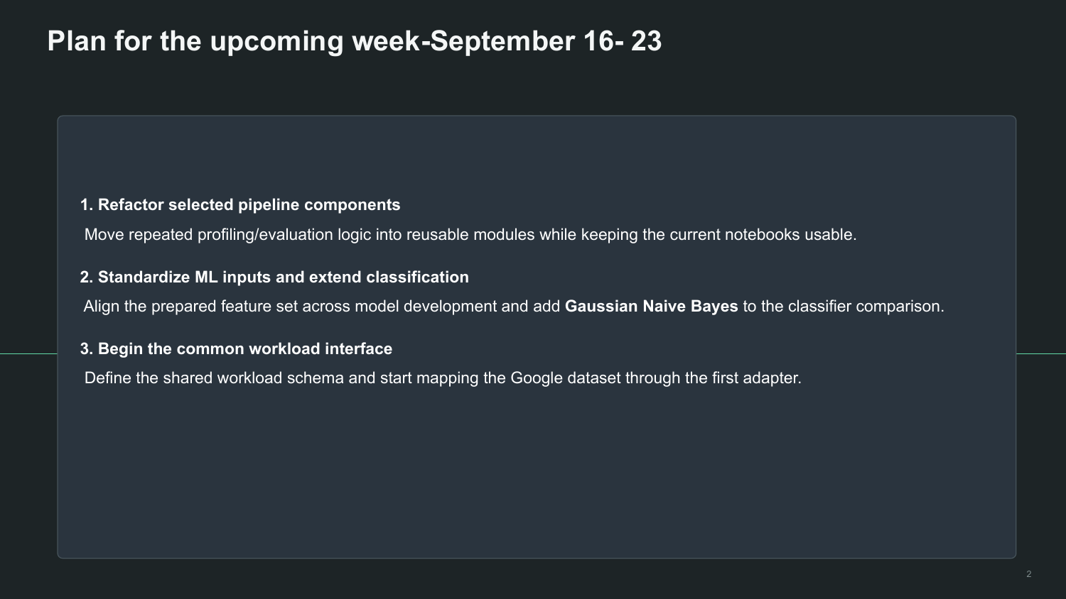
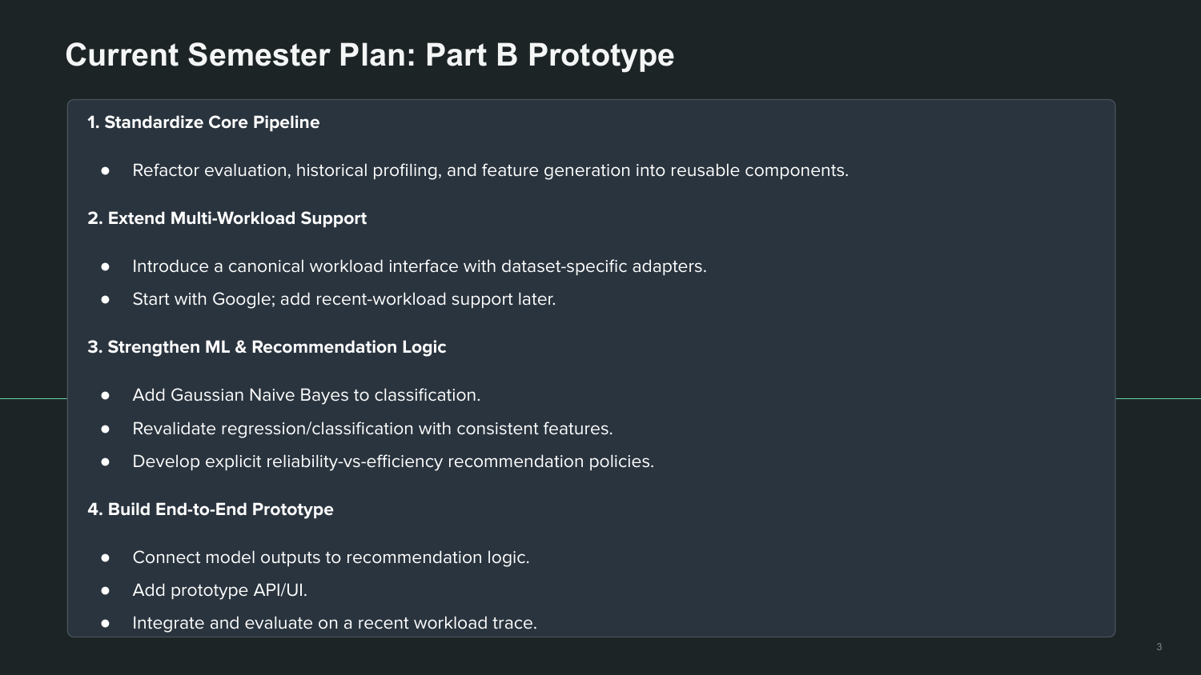

Meeting 6: Advisor – 2026-09-22
Meeting Type: Advisor
Date: 2026-09-22
Start–End Time: 9:30 AM – 10:00 AM
Location/Mode: Zoom
Attendees: Dan Harkey (Advisor), Meghana Koti, Sofia Silva, Sonali Lonkar, Shivani Jariwala

1) Accomplished Since Last Meeting
- Refactored notebooks 4–6 to use only historical data available before execution (PR #46).
- Standardized the ML features and added Gaussian Naive Bayes (PRs #47, #48).

2) Accomplished During This Meeting
- Presented the completed work and the regenerated evaluation results.
- Agreed on the plan for 09-22 to 09-28.

3) Issues / Blockers
- Found and fixed data leakage from future, overlapping and incomplete executions.

4) Action Items
- Action: Build the canonical workload interface and the Google adapter | Owner: Team | Due: 09-29
- Action: Create the shared evaluation metrics and evaluator | Owner: Team | Due: 09-29
- Action: Start the project report structure | Owner: Team | Due: 09-29

5) Plans / Goals for Next Meeting
- Review the new evaluator and the pipeline progress.

Evidence: Weekly Progress Presentation to Advisor
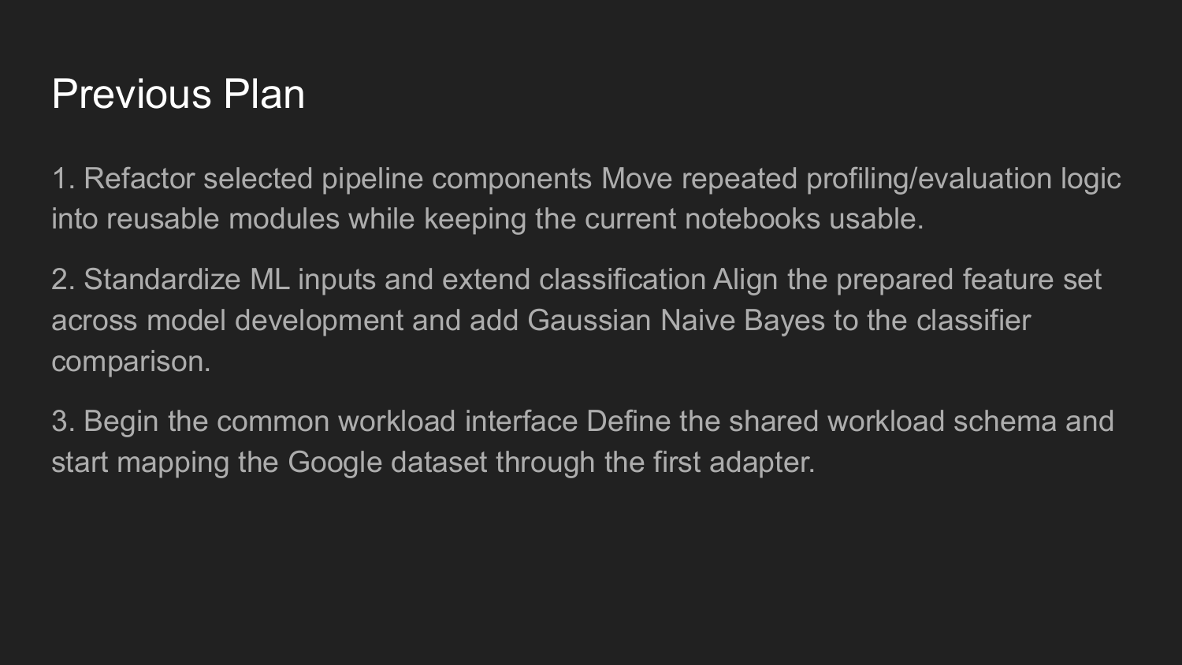
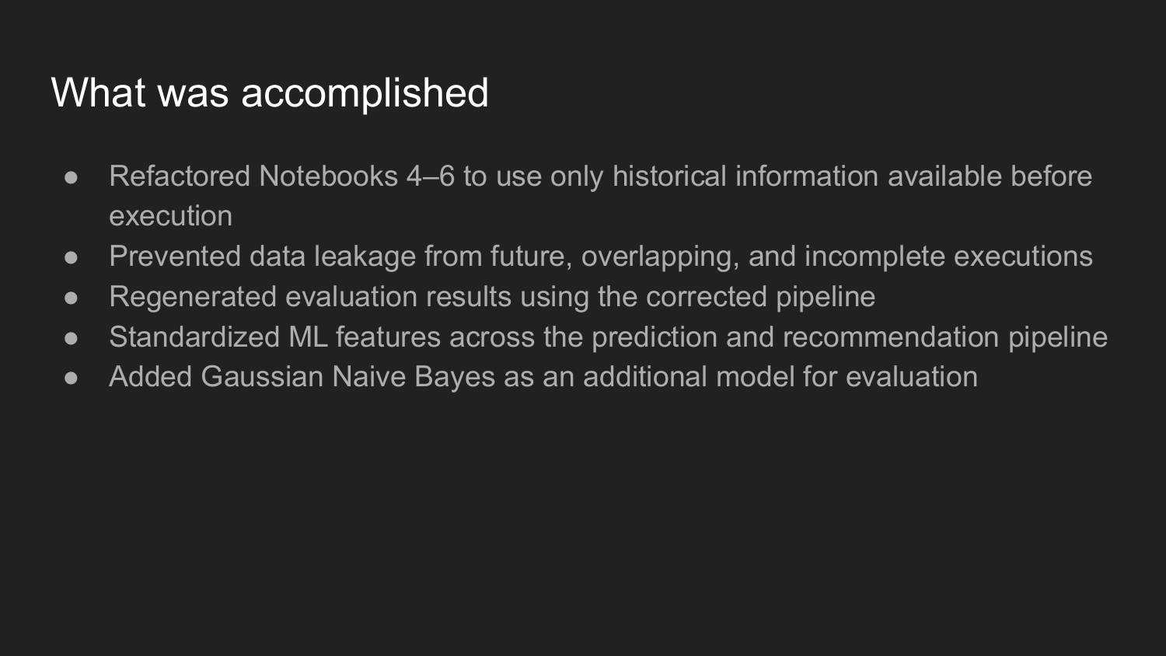
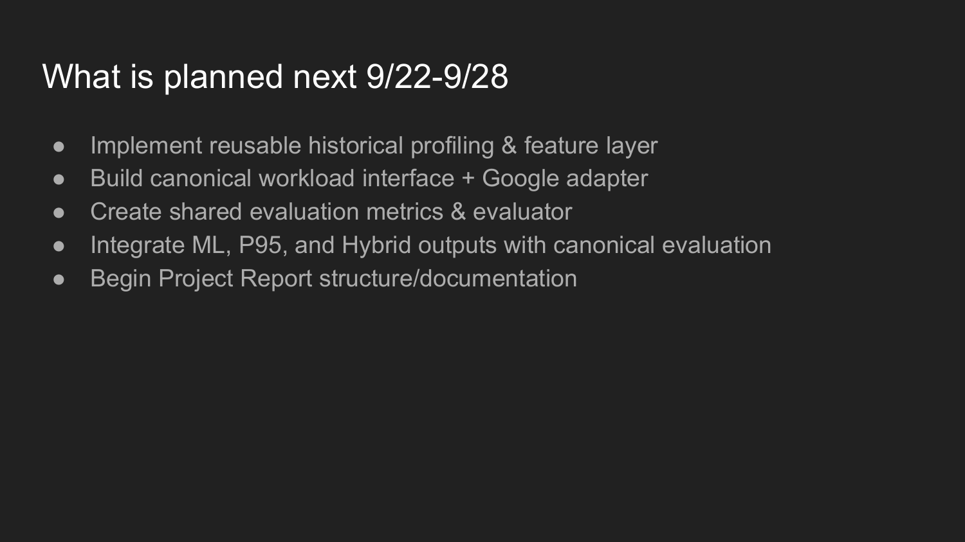
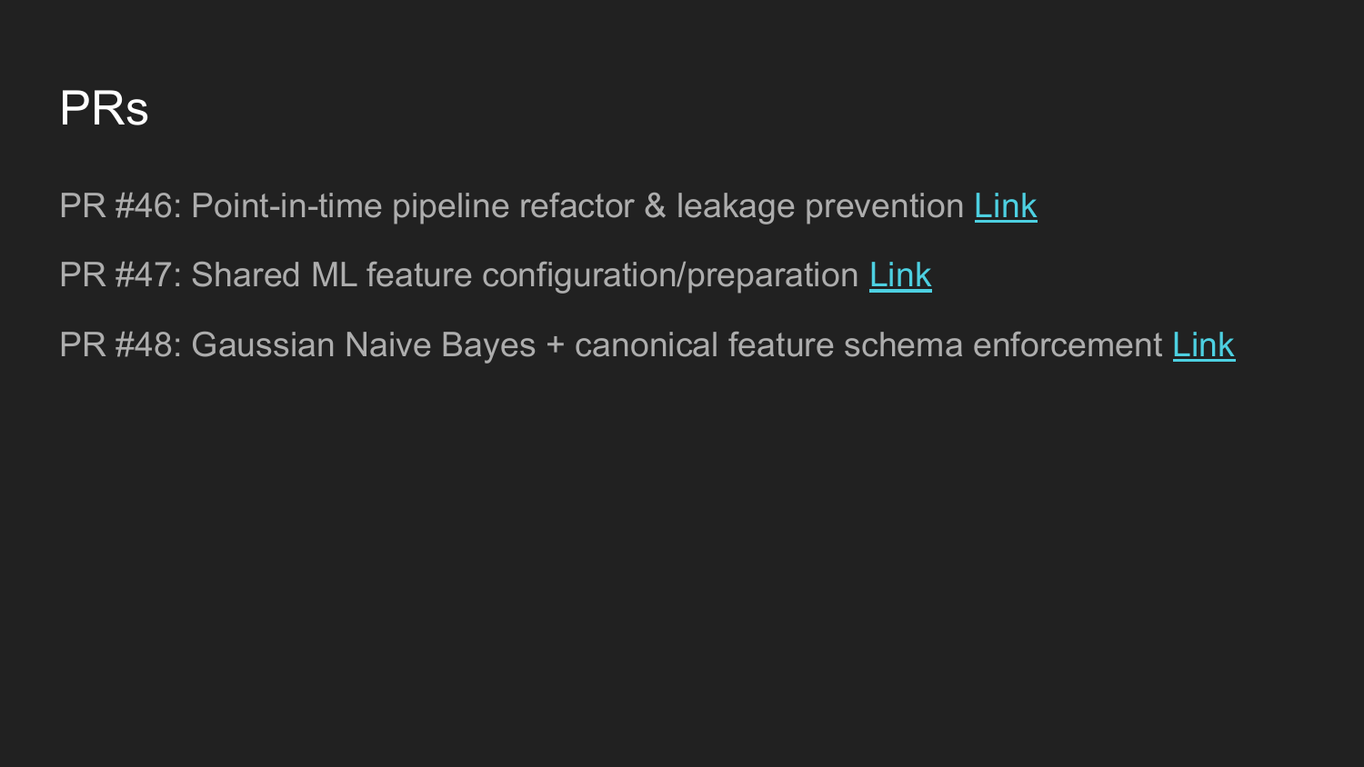

Meeting 7: Team-Only – 2026-09-24
Meeting Type: Team-Only
Date: 2026-09-24
Start–End Time: 8:00 PM – 9:00 PM
Location/Mode: Zoom
Attendees: Meghana Koti, Sofia Silva

1) Accomplished Since Last Meeting
- Meghana wrote a one-week task plan (three notebooks and two Python modules) in the shared document.

2) Accomplished During This Meeting
- Walked through the task plan and split the work: evaluation and metrics, data splitting (70/20/10), and the recurrence profile.
- Agreed to build the pipeline on the Google subset first, then extend it to the other workloads.

3) Issues / Blockers
- The updated data has more records and new columns (execution/episode), so the job profile logic needs changes.

4) Action Items
- Action: Email about the OpenStack workload data | Owner: Meghana
- Action: Build the recurrence profile and recommendation pipeline | Owner: Sofia | Due: 10-01
- Action: Build the evaluator and metrics modules | Owner: Meghana, Sofia | Due: 10-01

5) Plans / Goals for Next Meeting
- Review the pipeline progress and start on the adapter interface.

Meeting 8: Advisor – 2026-09-29
Meeting Type: Advisor
Date: 2026-09-29
Start–End Time: 9:30 AM – 10:00 AM
Location/Mode: Zoom
Attendees: Dan Harkey (Advisor), Meghana Koti, Sofia Silva, Sonali Lonkar, Shivani Jariwala

1) Accomplished Since Last Meeting
- Refactored the Google subset pipeline and fixed the execution reconstruction (PR #49).
- Built a reusable evaluation and metrics layer.

2) Accomplished During This Meeting
- Presented the completed work and agreed on the plan for 09-29 to 10-05.

3) Issues / Blockers
- The execution reconstruction in the earlier pipeline was incorrect.

4) Action Items
- Action: Integrate the ML, P95 and hybrid outputs with the new pipeline | Owner: Team | Due: 10-06
- Action: Build the historical profiling and feature layer | Owner: Team | Due: 10-06
- Action: Start the project report structure | Owner: Team | Due: 10-06

5) Plans / Goals for Next Meeting
- Review the historical profiles and the baseline results.

Evidence: Weekly Progress Presentation to Advisor
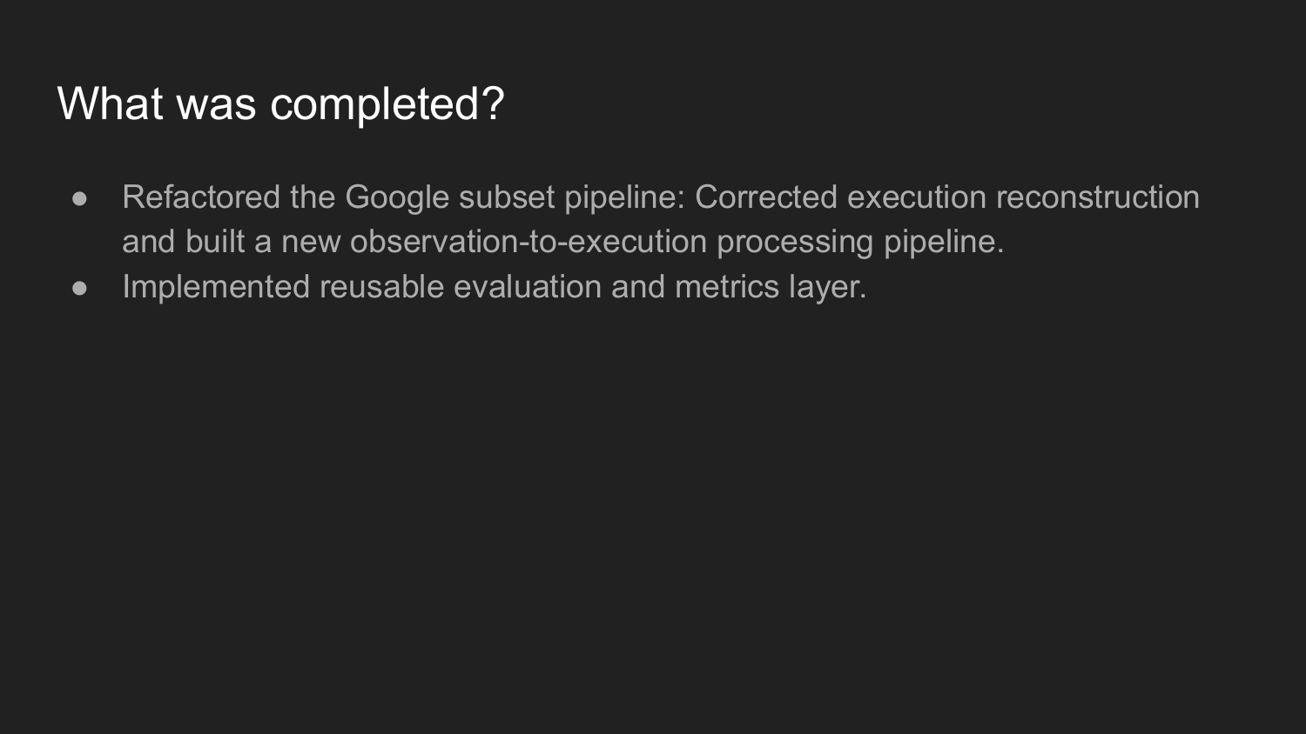
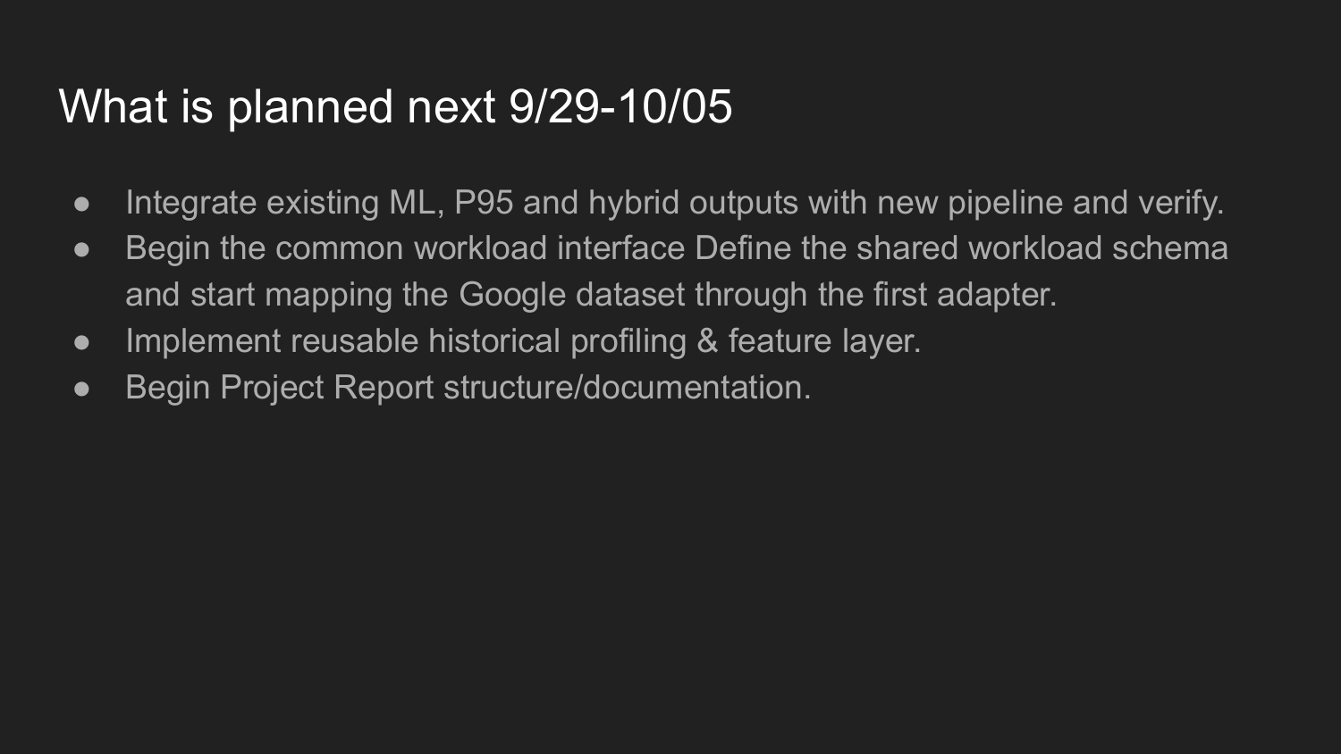
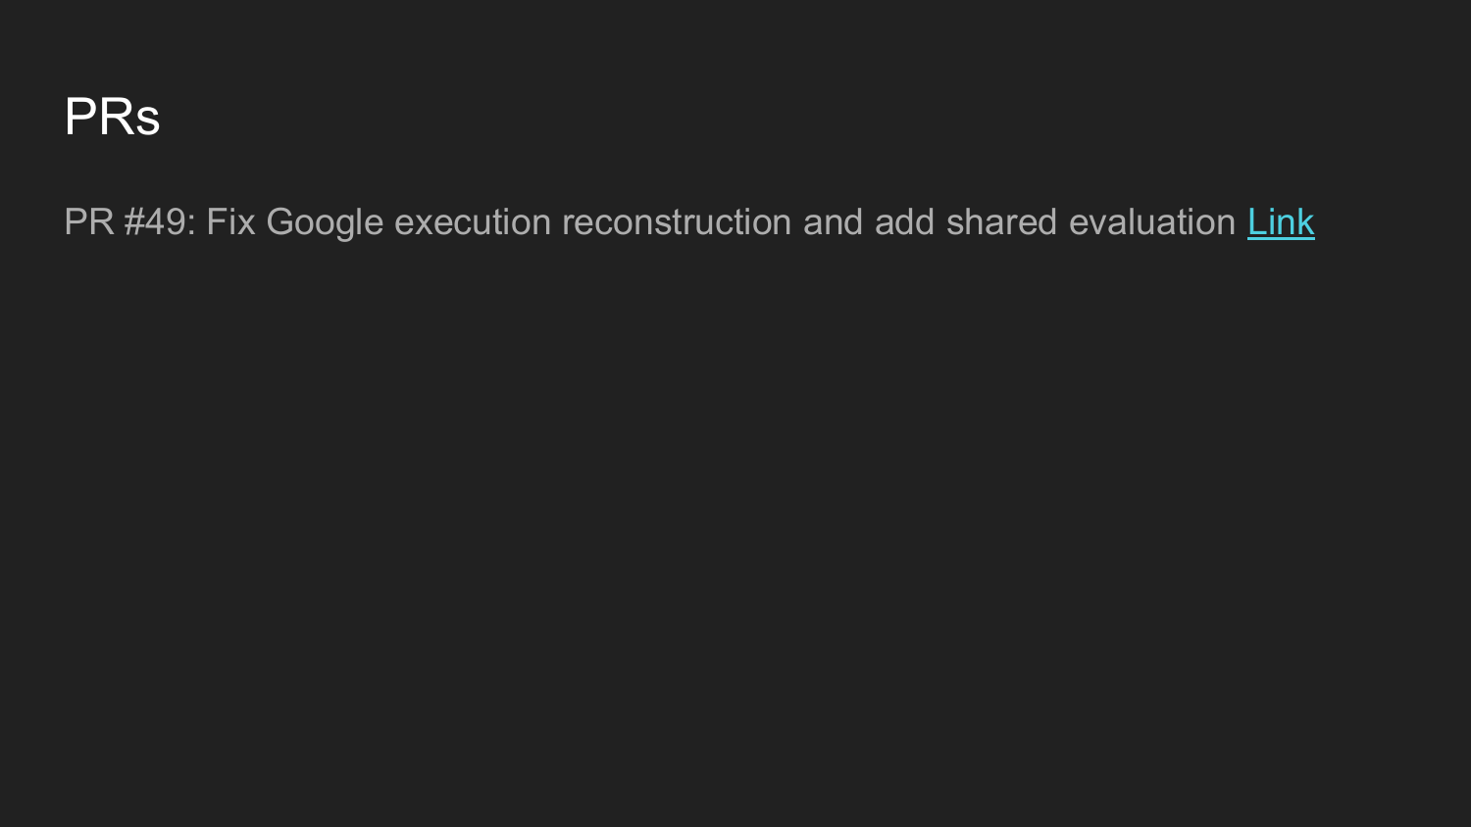

Meeting 9: Team-Only – 2026-09-29
Meeting Type: Team-Only
Date: 2026-09-29
Start–End Time: 8:00 PM – 9:00 PM
Location/Mode: Zoom
Attendees: Meghana Koti, Sofia Silva

1) Accomplished Since Last Meeting
- Finished the corrections to notebooks 3 and 4, including the fix to the CPU usage calculation.

2) Accomplished During This Meeting
- Chose the Alibaba and Azure VM workloads instead of OpenStack.
- Planned version 2.1 in this order: the dataset adapter and pipeline, then the backend APIs, then the UI with a policy slider (ML hybrid or P95 baseline).

3) Issues / Blockers
- The new datasets have different schemas, so they need preprocessing and a unified job schema.

4) Action Items
- Action: Create GitHub issues and research the adapter interface | Owner: Meghana | Due: 10-01
- Action: Re-run the ML models on the notebook 4 parquet file | Owner: Meghana | Due: 10-04
- Action: Update notebook 3 | Owner: Sofia
- Action: Update notebook 4 | Owner: Sonali

5) Plans / Goals for Next Meeting
- Review the adapter interface research and the re-run ML results.

Meeting 10: Advisor – 2026-10-06
Meeting Type: Advisor
Date: 2026-10-06
Start–End Time: 9:30 AM – 10:00 AM
Location/Mode: Zoom
Attendees: Dan Harkey (Advisor), Meghana Koti, Sofia Silva, Sonali Lonkar, Shivani Jariwala

1) Accomplished Since Last Meeting
- Built point-in-time historical profiles and validated 253K+ execution records (PRs #50, #51).
- Built chronological train/validation/test splits and the baseline policies (Request, Mean, P90, P95, P99) (PR #52).

2) Accomplished During This Meeting
- Presented the completed work and agreed on the plan for 10-06 to 10-12.

3) Issues / Blockers
- The target and history definitions are still under team review.
- There are minor issues in the new Google subset pipeline.

4) Action Items
- Action: Fix the minor pipeline issues | Owner: Team | Due: 10-13
- Action: Integrate the ML and hybrid outputs with the new pipeline | Owner: Team | Due: 10-13
- Action: Start the common workload interface and the project report | Owner: Team | Due: 10-13

5) Plans / Goals for Next Meeting
- Review the integrated ML results and the workload interface progress.

Evidence: Weekly Progress Presentation to Advisor
